 | Liebherr-Great Britain Ltd, Normandy Lane, Stratton Business Park, Biggleswade SG18 8QB |  |  |  | Liebherr-Great Britain Ltd  Sales & Service  Concrete Production Equipment  Earthmoving Products  Marine & Crawler Cranes  Mobile Cranes  Tower Cranes  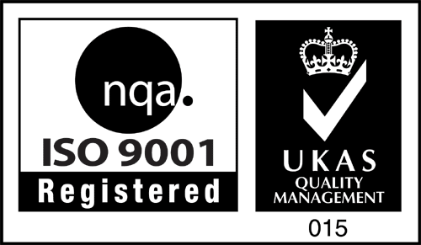  BS EN ISO 9001:2000 Certificate No: 3958
 | Your Ref: | Your letter dated: | Our Ref: | Date: | From the desk of: Adele Tagg
 |  |  | Defect
 |  |  |  |  | Telephone | +44 1942 | 528500
 |  |  |  |  | Telefax | +44 1942 | 271802
 |  |  |  |  | e-mail: adele.tagg@liebherr.com

Dear Sir,

MACHINE TYPE:- | R922 | SERIAL NUMBER:- | 49965 | HOURS:- | 612
During a recent visit to the above machine, our engineer reported the following defects:

- B159 fault

Should you require any further information on the above, please do not hesitate to contact the writer. I hope this information is of use to you and assures you of our best intention at all times.

Yours faithfully
For and on behalf of
LIEBHERR GB LTD
Adele Tagg
After Sales Administrator – Wigan

